**Rural Solid Waste Management in Gwalior - An uncovered solid waste**

Covered by : Unnati Yogi -0902cs231126 , Sanjana Jha- 0902CS231096

Bhumi Shah- 0902IT231014 , Unnati Patel- 0902IT231057

RUSTAMJI INSTITUTE OF TECHNOLOGY , Tekanpur Gwalior(MP)

**Abstract:** Solid waste refers to any non-liquid, discarded material that is deemed no longer useful or needed. It encompasses a wide variety of materials produced by households, industries, businesses, and institutions. Proper management of solid waste is crucial for environmental sustainability, public health, and resource conservation. This article focuses on the current state of waste collection in rural areas of Gwalior district, including the types of garbage generated in these regions. The article also examines common errors that occur during waste collection in these areas and provides suggestions for improving the process. Overall, the article emphasizes the importance of proper waste management in rural areas as well as urban areas too and highlights the urgent need for effective solutions to address this issue.

**Introduction:** Gwalior is located in Madhya Pradesh, India. **Gwalior** is a historic city located in the central Indian state of Madhya Pradesh. Known for its rich cultural heritage, architectural marvels, and strategic importance, Gwalior is often referred to as the "City of Scindia" due to its association with the Scindia dynasty.

**Geographical Location:**

* State: Madhya Pradesh
* Region: Chambal region
* Coordinates: 26.2183° N, 78.1828° E
* Elevation: Approximately 197 meters above sea level.

Gwalior lies in the northern part of Madhya Pradesh, near the border with Uttar Pradesh. It serves as a major regional hub for education, trade, and tourism.

**Historical Significance:**

Gwalior has a storied past that dates back over a millennium. It was founded by King Suraj Sen, who named it after a sage named Gwalipa. The city has been ruled by several dynasties, including the Tomars, Mughals, Marathas, and the Scindias, contributing to its diverse architectural and cultural heritage.

**Solid Waste Generation in Gwalior:**

1. **Sources of Waste**:
   * **Residential**: The primary contributor, including organic (food) waste, plastics, and paper.
   * **Commercial and Markets**: Produce significant quantities of organic waste, packaging materials, and plastics.
   * **Institutional**: Schools, hospitals, and offices generate paper waste, food waste, and some hazardous waste.
   * **Industrial**: Small and medium industries contribute non-hazardous and hazardous waste.
   * **Construction and Demolition (C&D)**: Inert materials like debris, concrete, and bricks.
   * **Healthcare Facilities**: Biomedical and hazardous waste.
2. **Waste Composition**:
   * **Organic Waste**: ~50-60% (kitchen and garden waste)
   * **Recyclable Waste**: ~15-20% (plastic, paper, metals, glass)
   * **Inert Waste**: ~20-25% (construction debris and ash)
   * **Hazardous Waste**: ~5% (batteries, electronic waste, and medical waste)
3. **Volume of Waste**:

* Approximately **350–400 metric tons of municipal solid waste (MSW)** is generated daily in Gwalior.
* Per capita waste generation ranges from **400 to 600 grams per day**.

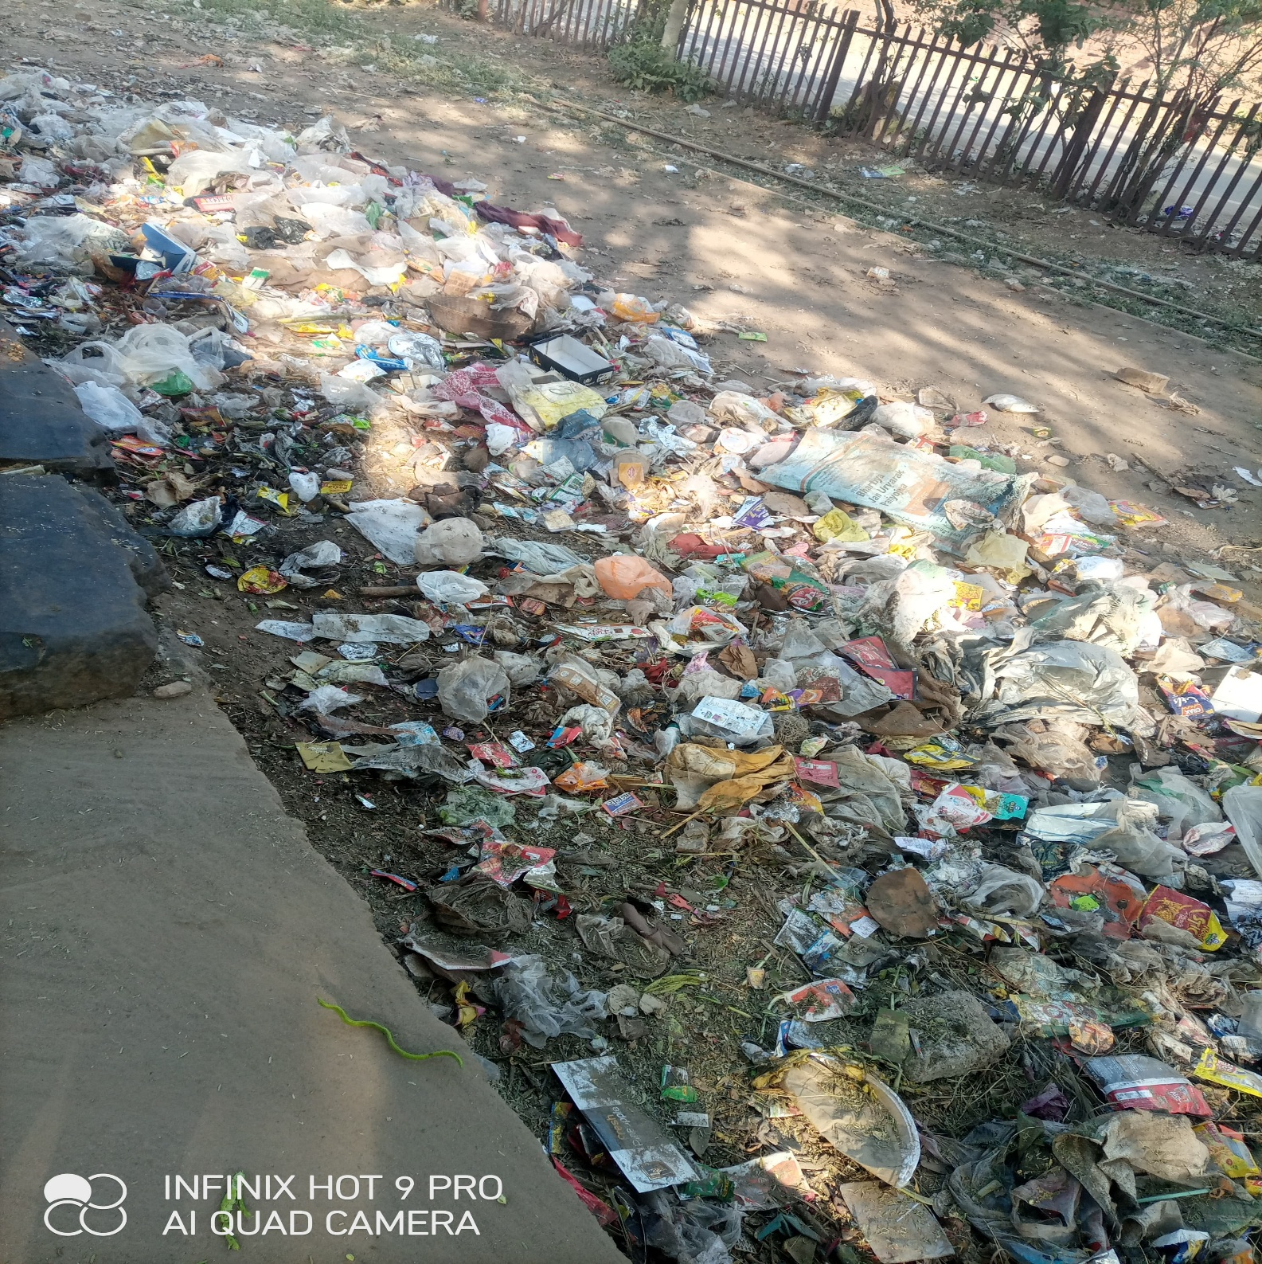Waste collected for several days and not treated properly and management is so poor in case of waste generation. Municipal does not take appropriate actions over waste management techniques and strict laws are prohibited. It shows irresponsibility of government and corporation. And hence it leads to a lot of waste generation and a lot of health diseases cause in the respective areas of waste generation.

**Solid Waste Management in Gwalior:**

1. **Current Practices**:

* **Collection**:
  + The Gwalior Municipal Corporation (GMC) oversees waste collection.
  + Door-to-door waste collection is implemented in some areas but is inconsistent.
  + Community bins are used in many neighborhoods but are often insufficient and poorly maintained.
* **Transportation**:
  + Waste is transported to dumping sites, but the logistics are outdated, leading to delays and inefficiencies.
* **Segregation**:
  + Minimal segregation at the source; most waste is mixed, complicating recycling and treatment processes.
* **Disposal**:
  + The majority of waste is dumped in open landfill sites without scientific treatment, leading to pollution.

1. **Recycling and Processing:**

* Limited recycling efforts due to lack of organized infrastructure.
* Informal waste pickers play a significant role in recycling but face health and safety risks.
* Composting and bio-methanation of organic waste are underutilized.

1. **Challenges in Waste Management**:

* Insufficient infrastructure for waste collection and processing.
* Lack of awareness about waste segregation and recycling.
* Inadequate enforcement of municipal solid waste rules.
* Limited funds and technical expertise for modern waste management systems

**Negative Effects of Improper Solid Waste Management:**

1. **Environmental Impacts**:

* **Air Pollution**:
  + Burning of mixed waste, especially plastics, releases toxic gases like dioxins and furans.
  + Methane emissions from decomposing organic waste contribute to climate change.
* **Water Pollution**:
  + Leachate from open dumps contaminates groundwater and nearby water bodies.
  + Rivers and streams in Gwalior, such as the Swarn Rekha, face pollution from waste disposal.
* **Soil Degradation**:
  + Dumping of hazardous waste, including chemicals, affects soil fertility.

1. **Health Impacts**:

* **Disease Transmission**:
  + Uncollected waste attracts pests, rodents, and stray animals, leading to diseases like dengue, malaria, and leptospirosis.
* **Respiratory Problems**:
  + Toxic fumes from burning waste cause respiratory issues among residents.
* **Infectious Diseases**:
  + Biomedical waste mixed with municipal waste increases the risk of infections.

1. **Economic Impacts**:

* Loss of recyclable materials due to improper segregation.
* Increased costs for cleanup and healthcare due to pollution-related illnesses.
* Negative impact on tourism due to unsightly waste and pollution.

1. **Social Impacts**:

* Communities near dumping sites suffer from foul odors, pollution, and degraded quality of life.
* Marginalized groups, such as informal waste pickers, face hazardous working conditions and social stigma.

**Proposed Measures for Effective Waste Management:**

* 1. **Segregation at Source**:
* Educate citizens about segregating waste into biodegradable, recyclable, and hazardous categories.
* Enforce regulations requiring waste segregation.
  1. **Improved Collection and Transportation**:
* Deploy modern waste collection vehicles with GPS tracking for efficient logistics.
* Increase the number of collection points and bins, ensuring regular maintenance.
  1. **Scientific Waste Processing**:
* Establish composting facilities for organic waste.
* Set up material recovery facilities (MRFs) for sorting and recycling.
* Develop waste-to-energy (WTE) plants for non-recyclable waste.
  1. **Proper Landfill Management**:
* Upgrade existing landfills to engineered sanitary landfills with leachate treatment and methane recovery systems.
* Close and remediate old dumpsites.
  1. **Public-Private Partnerships (PPP)**:
* Encourage private investment in waste management infrastructure and services.
* Collaborate with NGOs and startups to promote innovative solutions.
  1. **Regulation and Monitoring**:
* Strictly enforce municipal solid waste rules.
* Regular monitoring of waste management operations by independent agencies.
  1. **Community Engagement**:
* Conduct awareness campaigns about the importance of waste reduction, recycling, and responsible disposal.
* Introduce incentives for households and businesses that practice effective waste management.
  1. **Technology Integration**:
* Use GIS and IoT-enabled systems to monitor waste collection and landfill operations.
* Develop apps for citizen reporting of waste-related issues.

**Conclusion:**

The solid waste management system in Gwalior requires a comprehensive overhaul to address existing inefficiencies and mitigate the negative impacts of improper disposal. With a combination of public awareness, infrastructure development, and policy enforcement, Gwalior can transition toward sustainable waste management practices, ensuring a cleaner and healthier environment for its residents.